SWEET NECKLACE | 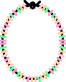
This is an easy way to make a very sweet, edible necklace or bracelet using licorice whips and Fruit Loops cereal and/or Cheerios. This is a good group activity for a child's party.
 | - Use long licorice whips for necklaces and short ones for bracelets - leave a lot of extra room for tying the ends.  - String the cereal onto the licorice whips.
- Tie the ends together.
- Wear and eat!

